

**Green University of Bangladesh**

Department of Computer Science and Engineering

**LAB REPORT**

**Course Code: CSE 202**

Course Name: **Object Oriented Programming Lab**

Date of submission: 29.10.2020

**Submitted By:**

Name: Md. Nur A Neouse

ID: 193002093

Department of CSE.

Green University Of Bangladesh

**Submitted To:**

Name: Feroza Naznin

Designation: Senior Lecturer

Department of CSE.

Green University Of Bangladesh

**Remarks:**

**Lab Report: 01**

**Problem Name:** A java program to add all odd numbers from N numbers.

**Objective:**

1. This program help us to know about the basics of JAVA.
2. We will learn to observe how loops and conditional statements work in an object oriented programming.

**Procedure:**

1. Start.
2. Open NetBeans and create a new class.
3. Declare 3 integer type variables – i, n, sum.
4. Initialize sum = 0.
5. Input a number by the user (using scan function) and put the number into n.
6. Execute a loop from 1 to n.
7. If i % n is not equal 0.
8. sum = sum + i.
9. Print sum.
10. End.

**Program Code (input):**

package javatutiriul;

import java.util.Scanner;

public class sumadd {

public static void main(String[] args)

{

int number, i, oddSum = 0;

Scanner sc = new Scanner(System.in);

System.out.print(" Please Enter any Number : ");

number = sc.nextInt();

for(i = 1; i <= number; i++)

{

if(i % 2 != 0)

{

oddSum = oddSum + i;

}

}

System.out.println("\n The Sum of Odd Numbers upto " + number + " = " + oddSum);

}

}

**Output:**

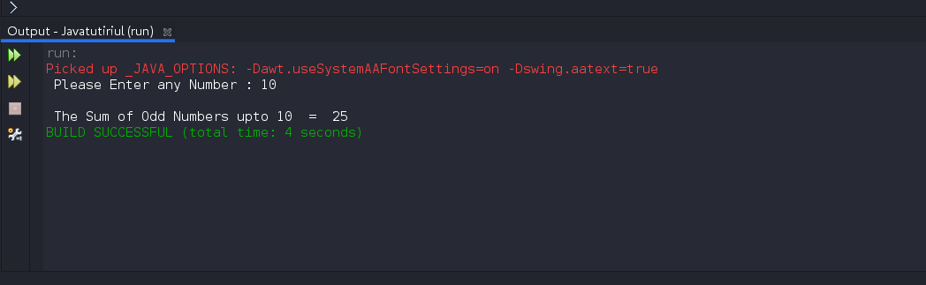

**Discussion:**

This program will help us to build up the basics foundation about object oriented

programming. We also learnt how to input and print something. In this program,

we used a for loop, a conditional statement, and sum of the odd number from 1 to N.